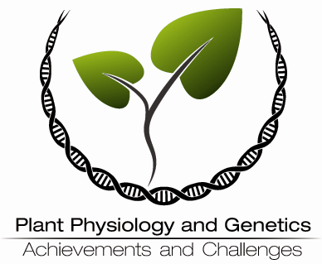 | Scientific Conference  Plant Physiology and Genetics – Achievements and Challenges  24–26 September 2014 – Sofia, Bulgaria  Organized by the Institute of Plant Physiology and Genetics  Bulgarian Academy of Sciences

ABSTRACT SUBMISSION FORM

Please send this document to the Organizers before 30 May 2014.
E-mail: ppgac@bio21.bas.bg

Personal information:
First Name: | ...
Family Name: | ...
Organization: | ...
Address: | ...
E-mail: | ...

Presentation type: Poster Oral Presentation Invited Lecture

I am interested to publish my presentation in the Conference Proceedings: Yes No

Abstract layout: Title, Authors, Addresses, Keywords, Abstract Body, Acknowledgements, Presenting author’s e-mail.
Approximate length: No more than 1800 symbols for Abstract body.
Font: Times New Roman.
Presenting author: Underlined.

Replace this sample with your Abstract.

ABSTRACT TITLE

Author¹, Presenting Author², Author¹, …

¹Address …
²Address …

Keywords: Up to six keywords characterizing the scope of the paper in alphabetical order.

Abstract body …

Acknowledgements: If any.

Presenting author: presenting-author@my-e-mail.com

Date: _________

